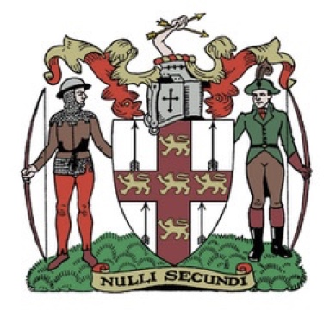
Northern Counties Archery Association.
Annual General Meeting
Saturday 15th March 2025 at 11.00 am

AGENDA.

- Welcome.
- Apologies for absence.
- Minutes of the previous meeting.
- Matters of accuracy.
- Officers reports.

  - President.
  - Chairman.
  - Vice Chairman
  - Treasurer
  - Secretary
  - Regional Coaching Officer
  - Judges Liaison Officer.
  - Junior Representative
  - Flight Representative.
  - Clout Representative.
  - Field Representative.
  - Public Relations Officer.
  - Archery England Rep.
  - Safeguarding Officer.
  - AGB Development Officer.

Approval of audited accounts.

Election of Officers.

President.

All other officers agreed to stand again.
President.
Chairman. Andrew Neal
Vice Chairman Peter Gregory
Treasurer Derek Pearson
Secretary Gaynor Moorhouse.
Regional Coaching Officer Danny Cameron
Judges Liaison Officer. Sharon Tideswell
Junior Representative Vacancy
Flight Representative. Tony Bakes
Clout Representative. Andrew Neal
Field Representative. Tony Tideswell
Public Relations Officer. Elaine Jobson
Archery England Rep. Carol Bladen / Andrew Neal / Chris Battersby
Safeguarding Officer. Carol Bladen

Any other nominations for the above posts.

